**Login to your Cognos account click on to the launch icon present in the left corner.**

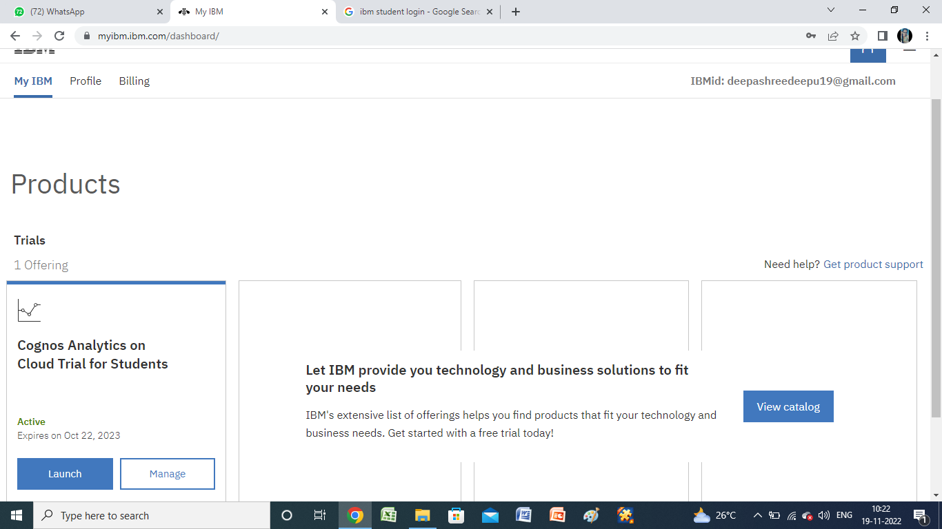

**Now Upload the data using the upload icon.**

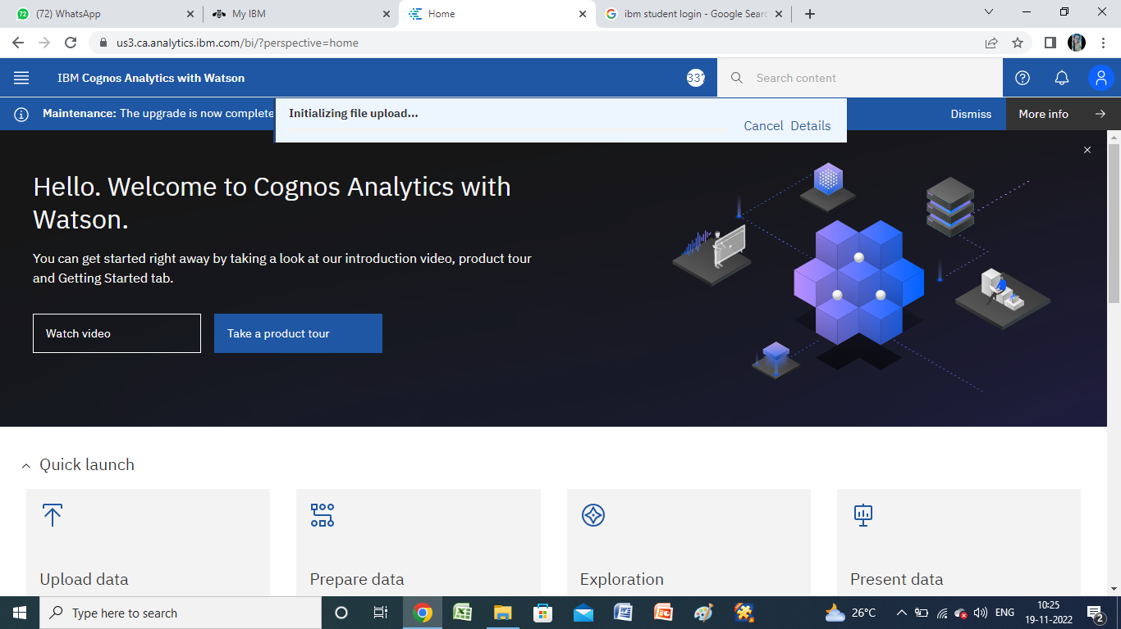

**After uploading the data click on to the present data you will find the Dashboard click on to that.**

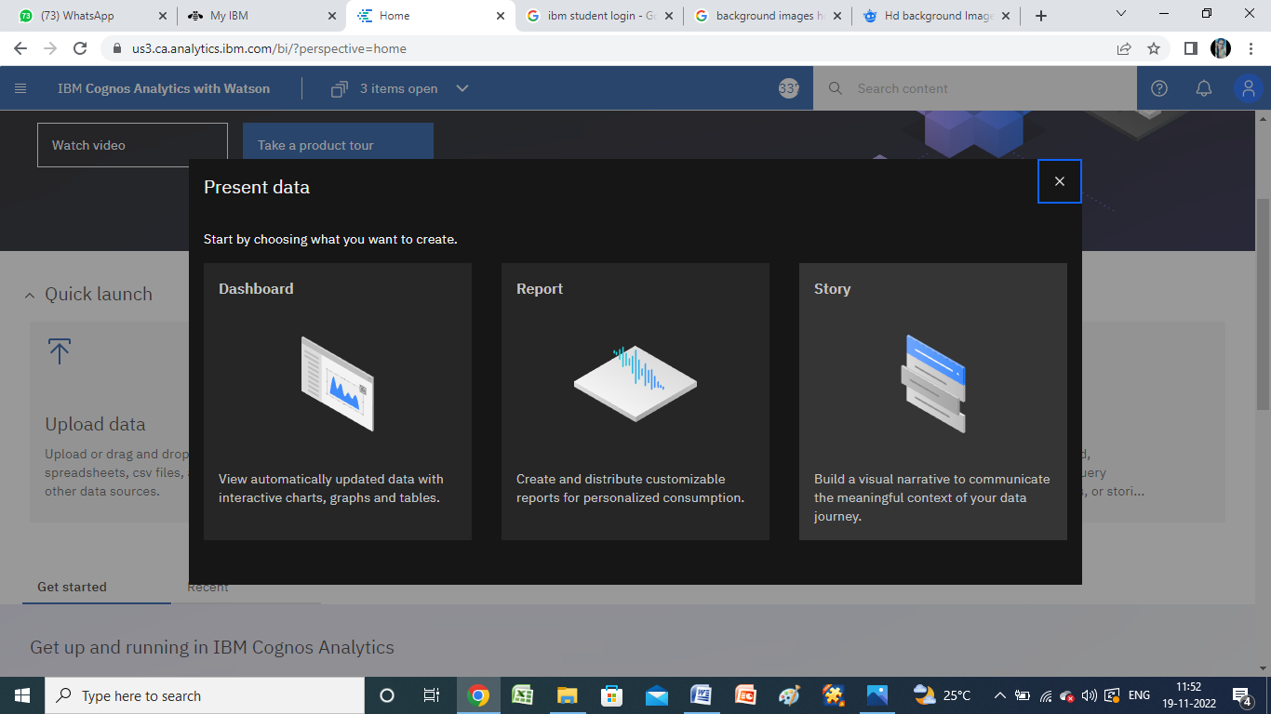

**Now you will directed to the dashboard and click on to the source file and select the data file that you saved.**

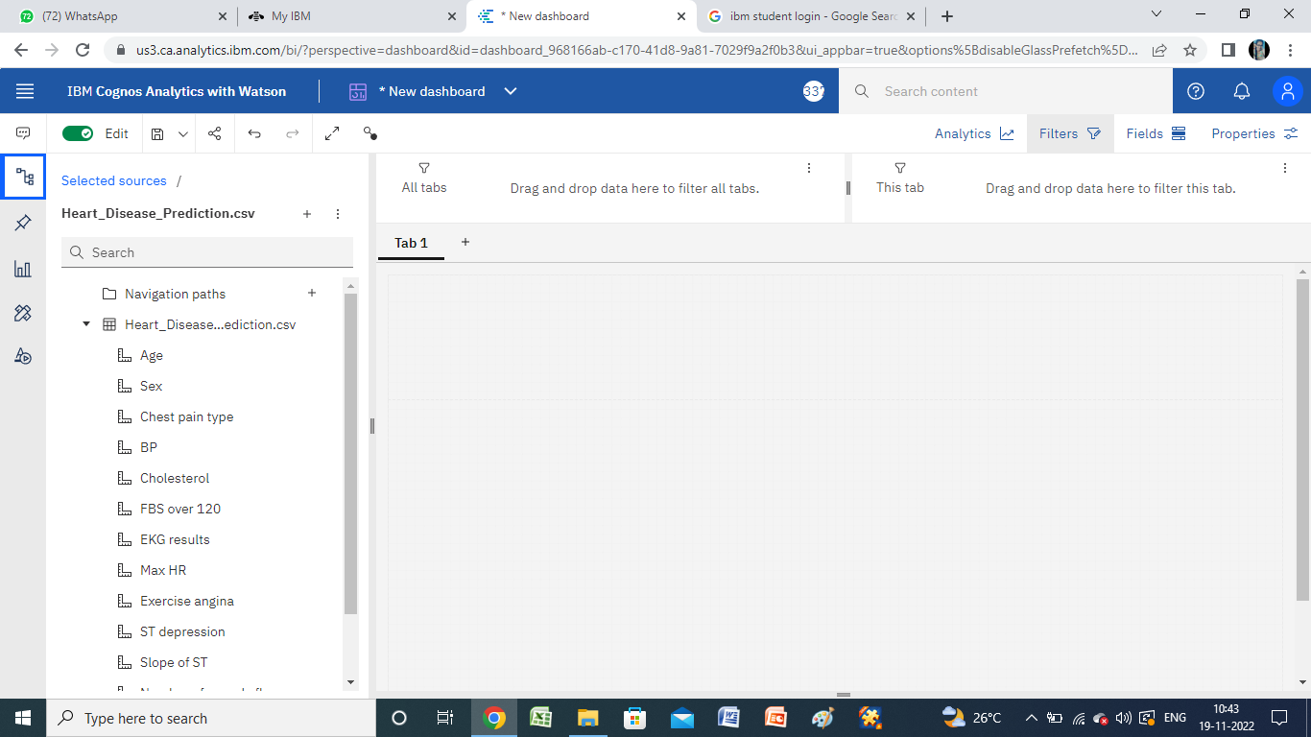

**Click on to the widgets and click on text then you will find a space to edit text and then edit the text by typing to the content relevant to your data.**

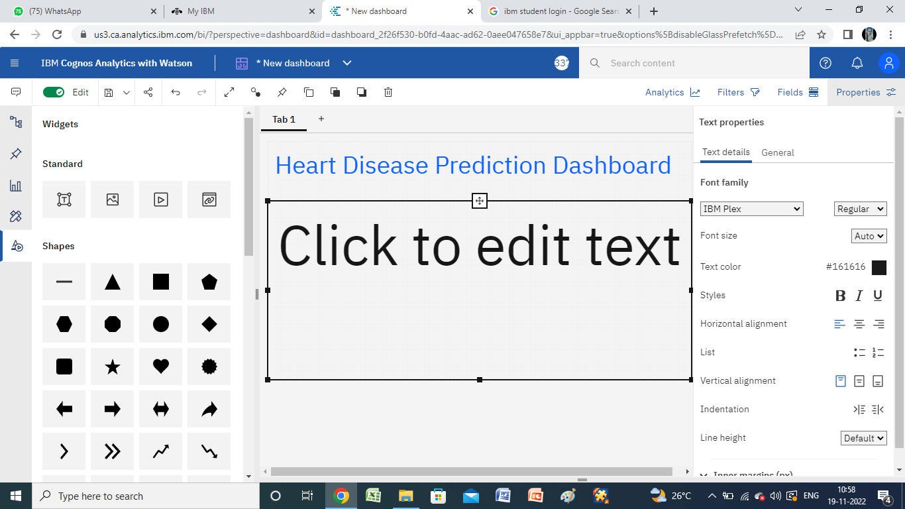

**Now in the selected sources you will find the data drag and drop them on the dashboard.**

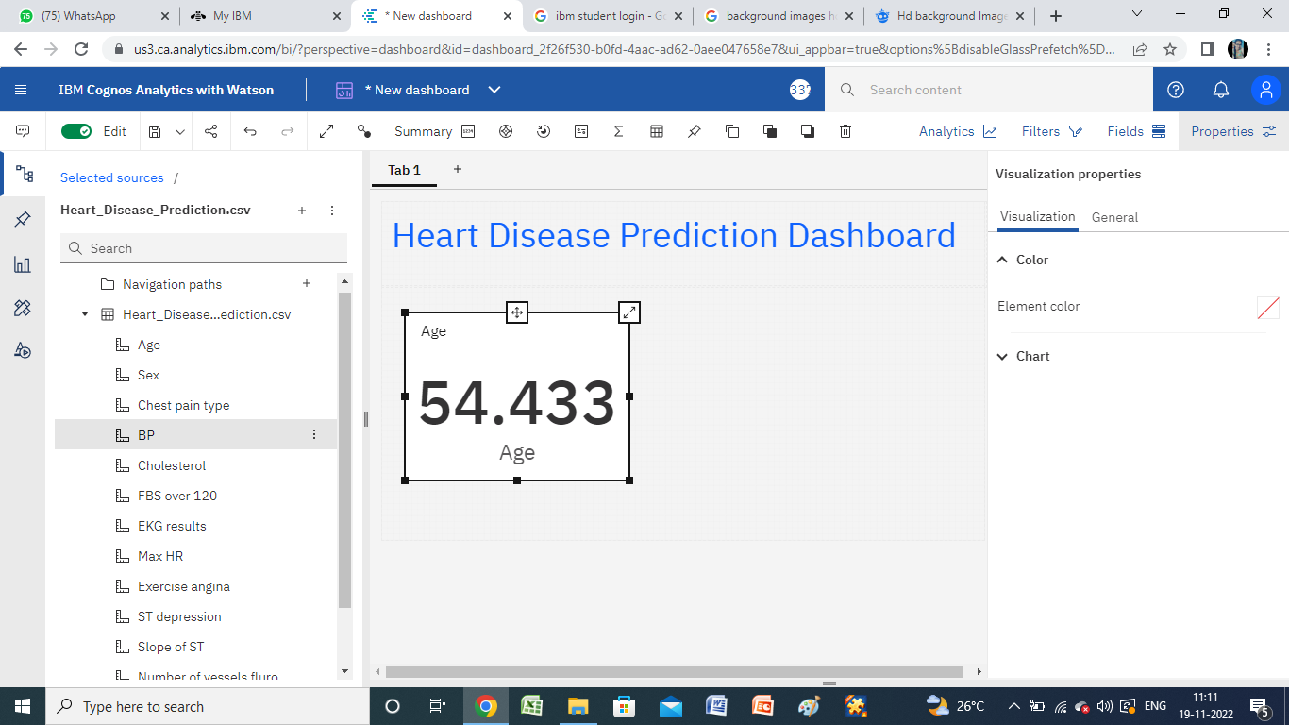

**Here in the left corner we have the graphs and the data can be represented in the graph by Drag and drop all the necessary details that are required and then click on to save to the content. Thus the Dashboard is created.**

